ISP
- Hostname
- hostnamectl set-hostname isp.au-team.irpo
- ip a
- vim /etc/net/sysctl.conf
- iptables -t nat -L
- iptables –t nat –A POSTROUTING –o ens3 –j MASQUERADE
- iptables-save >> /etc/sysconfig/iptables
- systemctl enable --now iptables
- timedatectl
HQ-RTR
- en
- sh hostname
- en
- conf t
- hostname HQ-RTR
- ip domain-name au-team.irpo
- end
- write memory
- sh ip interface brief
- sh users localdb
- sh interface tunnel.0
- en
- conf t
- interface tunnel.0
- ip address 10.10.10.1/30
- ip tunnel 172.16.1.2 172.16.2.2 mode gre
- end
- write memory
- sh ip route
- conf t
- ip route 0.0.0.0 0.0.0.0 172.16.1.1
- end
- write memory
- sh ip route
- en
- conf t
- router ospf 0
- network 10.10.100.0/27 area 0
- network 10.10.200.0/28 area 0
- network 10.10.30.0/29 area 0
- network 10.10.10.0/30 area 0
- passive-interface default
- no passive-interface tunnel.0
- area 0 authentication
- exit
- interface tunnel.0
- ip ospf authentication message-digest
- ip ospf message-digest-key 1 md5 P@ssw0rd
- end
- write memory
- С HQ-CLI выполнить: ping 172.16.1.1
- C HQ-RTR выполнить: show ip nat translations
- en
- conf t
- interface isp
- ip nat outside
- exit
- interface vl100
- ip nat inside
- exit
- interface vl200
- ip nat inside
- exit
- interface vl999
- ip nat inside
- exit
- ip nat pool HQ 10.10.0.1-10.10.200.254
- ip nat source dynamic inside-to-outside pool HQ overload interface isp
- end
- write memory
- show dhcp-server 1 detailed
- show ntp timezone
- en
- conf t
- ntp timezone utc+3
BR-RTR
- en
- sh hostname
- en
- conf t
- hostname BR-RTR
- ip domain-name au-team.irpo
- end
- write memory
- sh ip interface brief
- sh users localdb
- sh interface tunnel.0
- en
- conf t
- interface tunnel.0
- ip address 10.10.10.2/30
- ip tunnel 172.16.2.2 172.16.1.2 mode gre
- end
- write memory
- sh ip route
- conf t
- ip route 0.0.0.0 0.0.0.0 172.16.2.1
- end
- write memory
- sh ip route
- en
- conf t
- router ospf 0
- network 10.20.10.0/30 area 0
- network 10.10.10.0/30 area 0
- passive-interface default
- no passive-interface tunnel.0
- no passive-interface fw
- area 0 authentication
- exit
- interface tunnel.0
- ip ospf authentication message-digest
- ip ospf message-digest-key 1 md5 P@ssw0rd
- exit
- interface fw
- ip ospf authentication message-digest
- ip ospf message-digest-key 1 md5 P@ssw0rd
- end
- write memory
- show ip nat translations
- en
- conf t
- interface isp
- ip nat outside
- exit
- interface fw
- ip nat inside
- exit
- ip nat pool BR 10.0.0.1-10.254.254.254
- ip nat source dynamic inside-to-outside pool BR overload interface isp
- end
- write memory
- show ntp timezone
- en
- conf t
- ntp timezone utc+3
HQ-SW
- hostname
- hostnamectl set-hostname hq-sw.au-team.irpo
- ip a
- ovs-vsctl show
HQ-SRV
- hostname
- hostnamectl set-hostname hq-srv.au-team.irpo
- ip a
- vim /etc/net/ifaces/ens3/options
- vim /etc/net/ifaces/ens3/ipv4address внести айпи – 10.10.100.2/27
- vim /etc/net/ifaces/ens3/ipv4route внести инфу – default via 10.10.100.1
- vim /etc/net/ifaces/ens3/resolv.conf внести инфу
search au-team.irpo
name server 77.88.8.8
nameserver 127.0.0.1
- systemctl restart network
- vim /etc/passwd
- vim /etc/group
- visudo
- vim +123 /etc/sudoers
wheel_users all=(all:all) nopasswd: all
убрать хештег
- vim /etc/openssh/sshd_config
- vim /etc/openssh/sshd_config
Найти строчку # no default banner path
Ниже под строчкой ввести инфу: banner /etc/openssh/banner
- vim /etc/openssh/banner
Ввести инфу: Authorized access only
- systemctl restart sshd
- vim /etc/bind/options.conf
- vim /etc/bind/rfc1912.conf
Вывод:
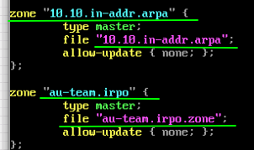

- vim /etc/bind/zone/au-team.irpo.zone
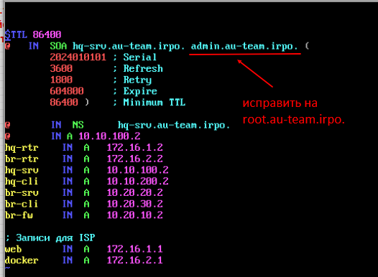
- vim /etc/bind/zone/10.10.in-addr.arpa
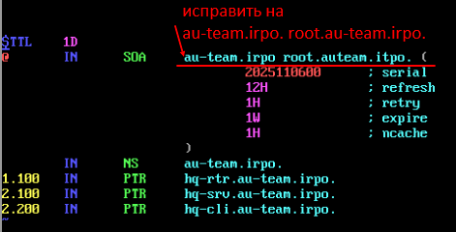
- vim /etc/bind/options.conf
- vim /etc/bind/zone/au-team.irpo.zone
Ввести инфу
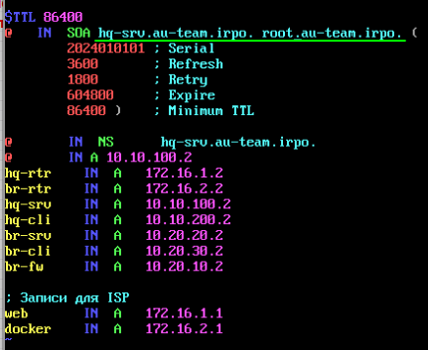
- vim /etc/bind/zone/10.10.in-addr.arpa
Ввести инфу
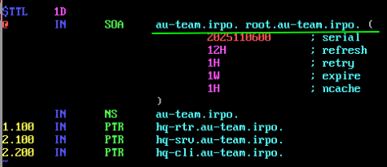
- systemctl enable --now bind.service
- timedatectl
HQ-CLI
- hostname
- hostnamectl set-hostname hq-cli.au-team.irpo
- ip a
- timedatectl
BR-CLI
- hostname
- hostnamectl set-hostname br-cli.au-team.irpo
- ip a
- su –
- mv /etc/net/ifaces/ens18 /etc/net/ifaces/ens3
- vim /etc/net/ifaces/ens3/options
- vim /etc/net/ifaces/ens3/ipv4address
Внести в файл информацию
- vim /etc/net/ifaces/ens3/ipv4route
Внести в файл информацию
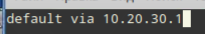
- vim /etc/net/ifaces/ens3/resolv.conf
Внести в файл информацию
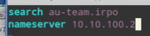
- systemctl restart network
- reboot
- timedatectl
BR-SRV
- hostname
- hostnamectl set-hostname br-srv.au-team.irpo
- ip a
- vim /etc/net/ifaces/ens3/options
- vim /etc/net/ifaces/ens3/ipv4address
Внести в файл информацию


- vim /etc/net/ifaces/ens3/ipv4route
Внести в файл информацию
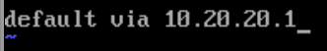

- vim /etc/net/ifaces/ens3/resolv.conf
Внести в файл информацию
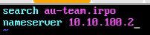

- systemctl restart network
- vim /etc/passwd
- vim /etc/group
- visudo
- vim +123 /etc/sudoers
- vim /etc/openssh/sshd_config
- vim /etc/openssh/sshd_config
Внести в файл информацию

- vim /etc/openssh/banner
Внести в файл информацию

- systemctl restart sshd
- timedatectl
BW-FW (НАСТРАИВАТЬ ЧЕРЕЗ BR-CLI)
- 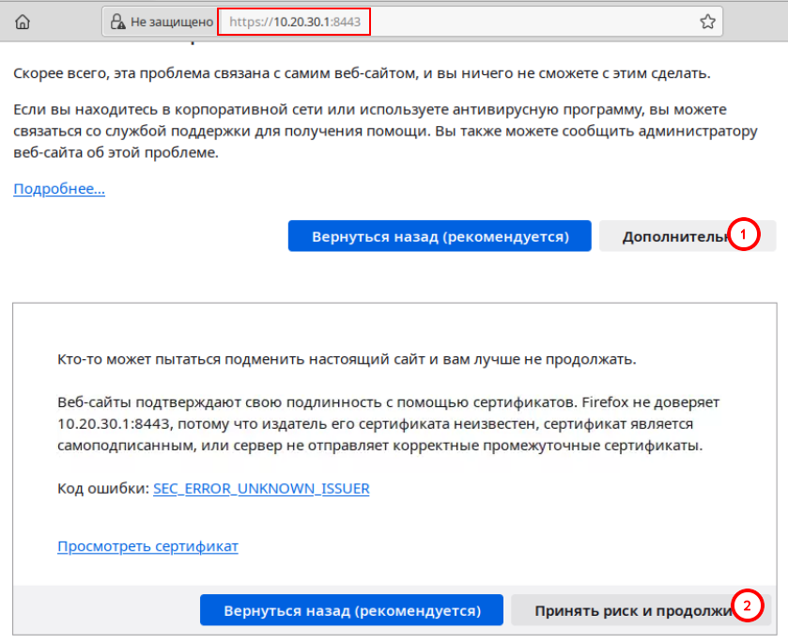
- Логин: Admin Пароль: IdecoP@ssw0rd
- 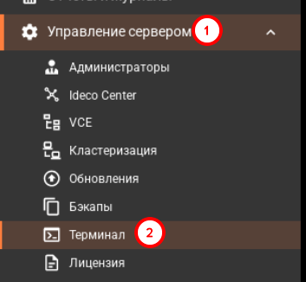
- Hostname
- hostnamectl set-hostname br-fw.au-team.irpo
- ip a
- 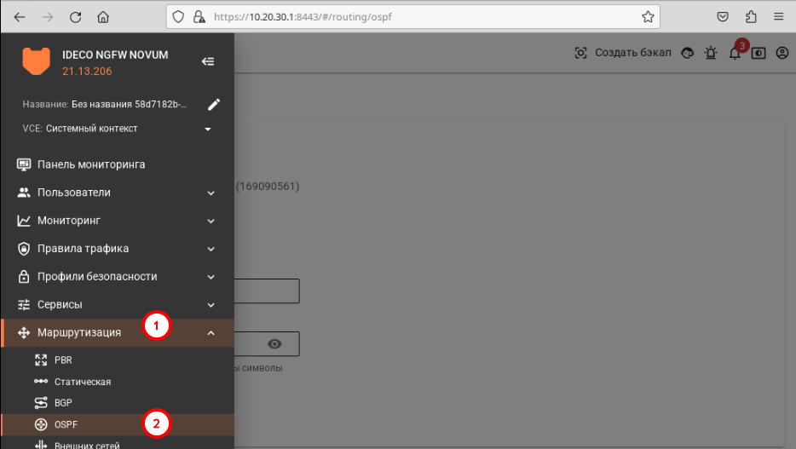
- 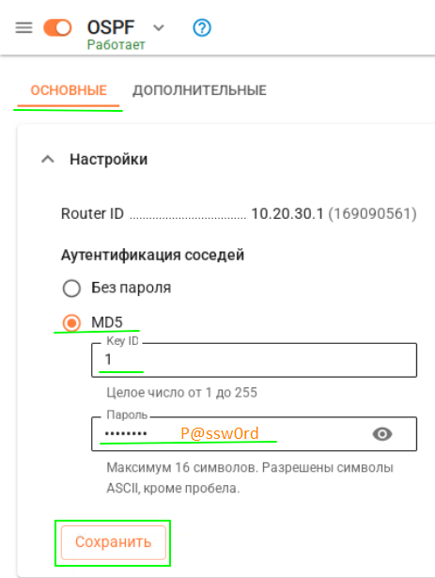
- 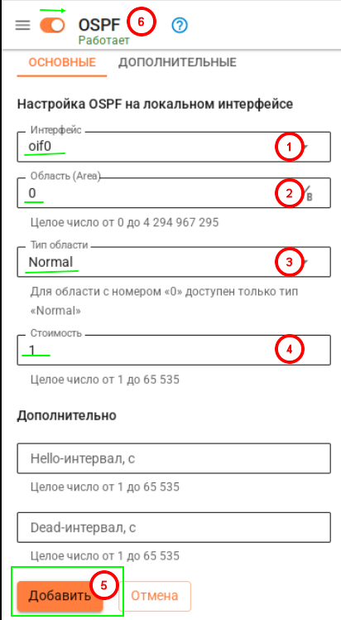
- Timedatectl
Конец

